**Timeline Static Testing Report**

1. **Background**
2. Language: C# .Net
3. UI Framework : WPF
4. IDE: Visual Studio
5. Static Testing Tool : Resharper
6. **Overview**

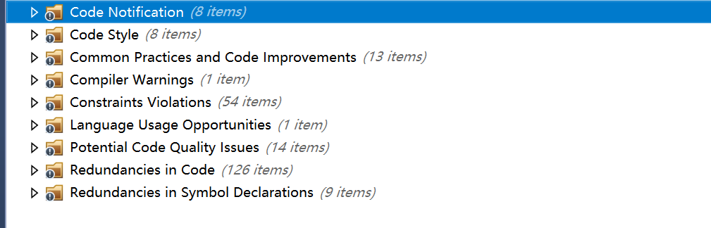

1. **Details**
2. Code Style

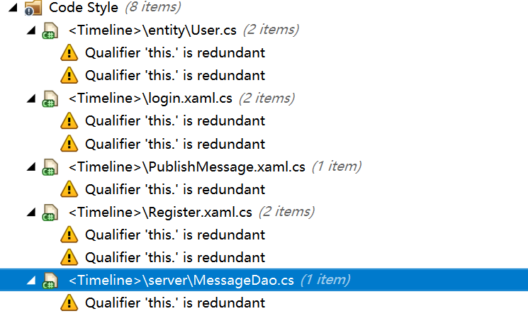

1. Code Practices and Code Improvements

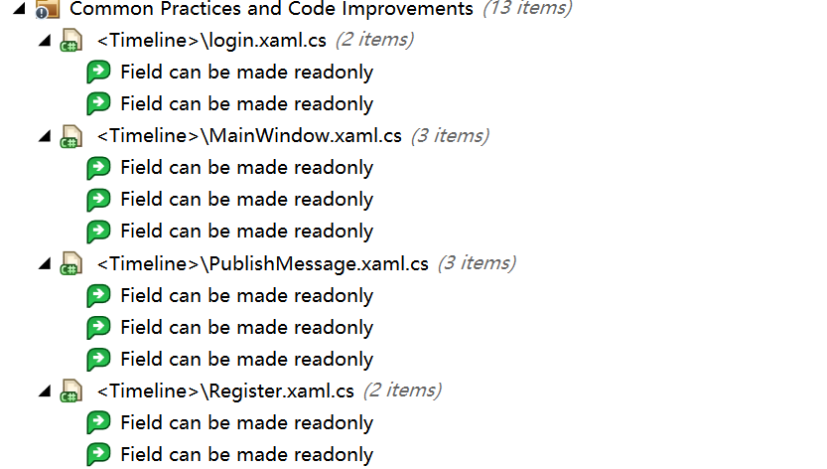

1. Compiler Warnings



1. Constraint Violations

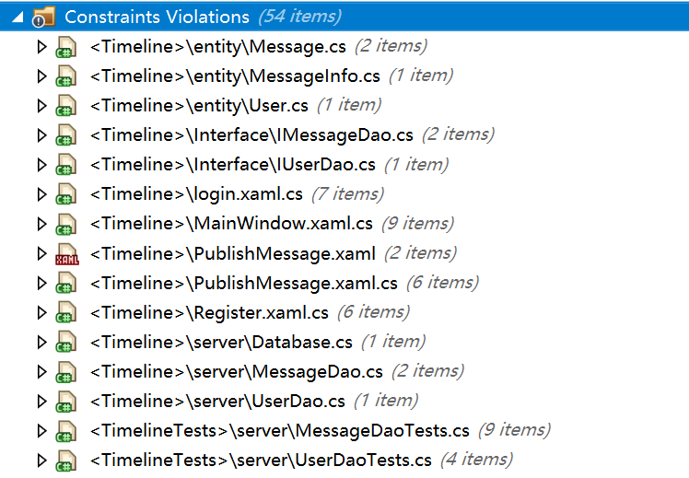

1. Language Usage Opportunities



1. Potential Code Quality Issues

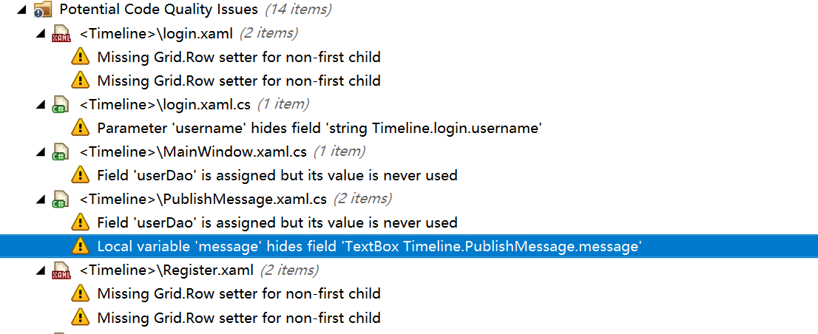

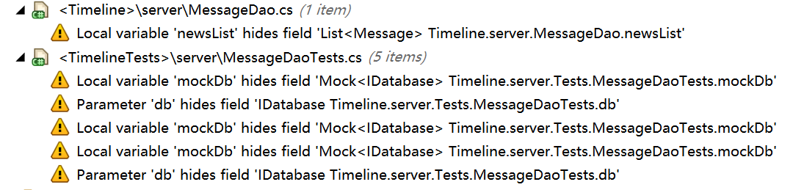

1. Redundancies in Code

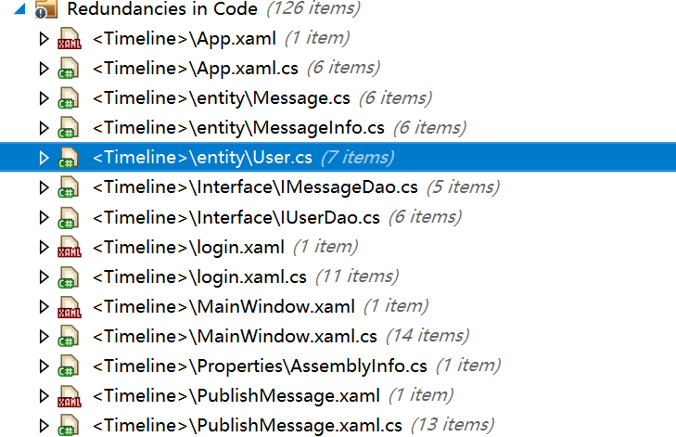

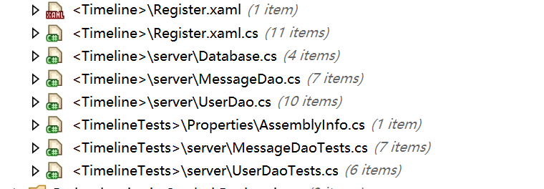

1. Redundancies in Simple Declaration

